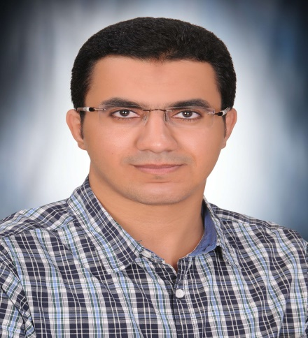  PERSONAL INFORMATION |  | Khaled Abdelsattar Kassem Mohammed
 | Department of Cardiothoracic Surgery, Faculty of Medicine, Assiut University Assiut ,Egypt.
 | +02 (01064479771)
 | dr_khaledkassem@yahoo.com and khaled.abdelsattar@aun.edu.eg
 | www.aun.edu.eg/arabic/membercv.php?M_ID=6775
 | Sex Male | Date of birth 18/10/1990 | Nationality Egyptian

STUDIES APPLIED FOR | Cardiothoracic Surgery

WORK EXPERIENCE

November 2018- now  March 2015– November 2018  March 2014 –February 2015 | Assistant lecturer cardiothoracic surgery  Assiut University Heart Hospital, Assiut, Egypt.  Cardiothoracic Surgery Resident  Assiut University Heart Hospital, Assiut, Egypt.  House Officer
 | Assiut University Hospital, Assiut, Egypt.
 | - I received training of 2 months in each of the following specialities: - Internal Medicine, General Surgery, Gynaecology and Obstetrics, Paediatrics, Emergency and Anaesthesia.

EDUCATION AND TRAINING
April 2018  March 2014 –February2015:  September 2007- December2013 : | Master of Science (M.Sc.) [ General Surgery]:  Faculty of Medicine, Assiut Univ. Hospital, Assiut, Egypt, April, 2018; Good. Review article title" Risk stratified outcome of congenital heart surgery in Assiut University Hospital 10 years analysis "  House-officer,  Assiut Univ. Hospital, Assiut, Egypt  Medical Student,  Faculty of Medicine, Assiut Univ., Assiut, Egypt  Graduation: Bachelor’s Degree in Medicine and Surgery: Faculty of Medicine, Assiut Univ., Assiut, Egypt, September, 2013; Excellent with honor degree.

PERSONAL SKILLS

Clinical skills | During my work as a house officer, as a resident and as an assistant lecturer, I gained experience in the following activities:  - Out-patient clinical management,  - In-patient clinical management,  - Management of traumatized patients,  Emergency surgery: in the emergency unit of my department concerned with the reception of cases like all kinds of blunt thoracic trauma including fracture ribs, flail chest, traumatic haemo and Pneumothoacis, Penetrating traumas including firearms and stab wounds to the pericardium and thoracic cavity where most of the cases are managed by me as main surgeon or assisting more junior surgeons in the trauma unit in my university hospital.  Elective surgery, including: -  Thoracic surgery: - I acted as a main surgeon or assisted by a senior surgeon in rigid esophagoscopies, Rigid bronchoscopy, foreign body extraction, Thoracotomies, Decortications, Pulmonary resections including lobectomies and sgmentectomies, mediatinal tumor excisions, chest wall resections and reconstruction, diaphragmatic hernia repair and Tracheo esophageal fistula repair.  Cardiac Surgery: - I acted as a main surgeon or assisted by a senior surgeon Opening and closure of sternotomies, Aorto bicaval cannulation, femoral cannulation, Saphenous vein graft, radial artery and left internal mammary harvesting, Secondom atrial septal defects closure, PDA ligation, sub-aortic membrane excision and mitral and aortic valve replacement, proximal anastomosis in CABG.  I assisted a more senior surgeon in CABG either on pump or Off pump, mitral and aortic valve replacements, minimally invasive mitral valve replacement, minimally invasive ASDclosure, ascending aortic and aortic root replacement, pericardiecomy for constrictive pericarditis, and an array of congenital cardiac surgeries including ASD and VSD closure, Tetralogy of Fallot repair, coarctaion of the aorta.

Computer skills  Other skills | Good command of Microsoft Office™ tools.  -Since we do not have a school for perfusionists in Egypt so most of surgeons including me have good command of cardiopulmonary bypass.  -I successfully completed the cognitive and skills evaluation in accordance with the curriculum of the American Heart Association Advanced cardiovascular Life Support.

Publications | Khaled Abdelsattar Kassem Mohammed*, Mostafa Alaa El-Din Abd-Elaziz, Ahmed M. Fathy Ghoniem, Ahmed Ibrahem Ismael.  "Risk stratified outcome of congenital heart surgery in Assiut University Hospital 10 years analysis ".  Faculty of Medicine, Cardiothoracic Surgery Department, Assiut University Heart Hospital, Assiut, Egypt.

N.B: All Certificates are available on demand
Thank you for the precious time spent reviewing this resume. I will have pleasure to be a member of your research team.

